**Chapter 7**

**Parametric Equations and Polar Coordinates**

**7.3 Polar Coordinates**

**Section Exercises**

**In the following exercises, plot the point whose polar coordinates are given by first constructing the angle  and then marking off the distance *r* along the ray.**

125. 

Answer:

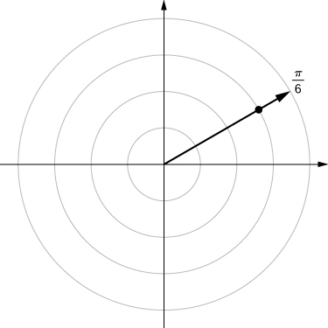

127. 

Answer:

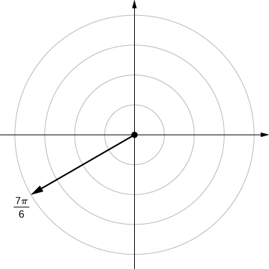

129. 

Answer:

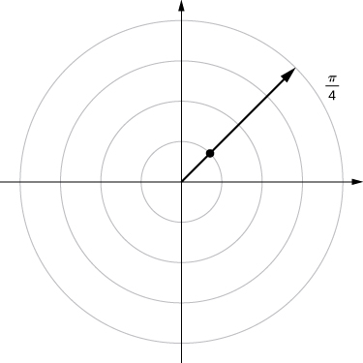

131. 

Answer:

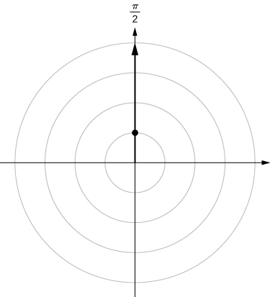

**For the following exercises, consider the polar graph below. Give two sets of polar coordinates for each point.**

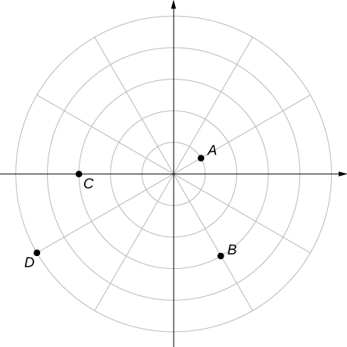

133. Coordinates of point *B*.

Answer: 

135. Coordinates of point *D*.

Answer: 

**For the following exercises, the rectangular coordinates of a point are given. Find two sets of polar coordinates for the point in  Round to three decimal places.**

137.  (3,–4)

Answer: 

139. 

Answer: 

141. 

Answer: 

**For the following exercises, find rectangular coordinates for the given point in polar coordinates.**

143. 

Answer: 

145. 

Answer: 

147. 

Answer: 

**For the following exercises, determine whether the graphs of the polar equation are symmetric with respect to the-axis, the-axis, or the origin.**

149. 

Answer: Symmetry with respect to the *x*-axis, *y*-axis, and origin.

151. 

Answer: Symmetric with respect to *x*-axis only.

153. 

Answer: Symmetry with respect to *x*-axis only.

**For the following exercises, describe the graph of each polar equation. Confirm each description by converting into a rectangular equation.**

155. 

Answer: Line 

157. 

Answer: 

**For the following exercises, convert the rectangular equation to polar form and sketch its graph.**

159. 

Answer: Hyperbola; polar form  or 

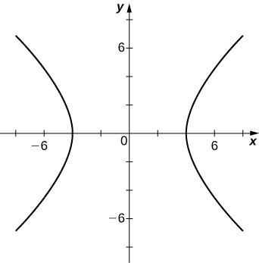

**For the following exercises, convert the rectangular equation to polar form and sketch its graph.**

161. 

Answer: 

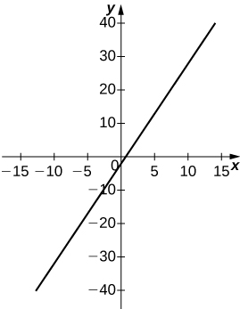

**For the following exercises, convert the polar equation to rectangular form and sketch its graph.**

163. 

Answer: 

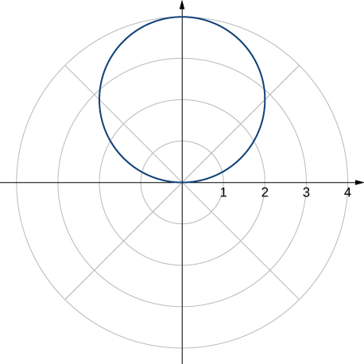

165. 

Answer: 

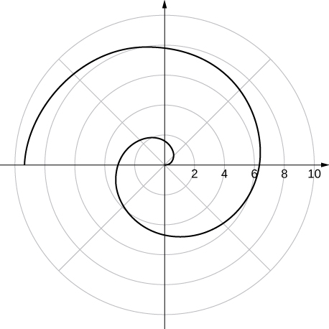

**For the following exercises, sketch a graph of the polar equation and identify any symmetry.**

167. 

Answer:

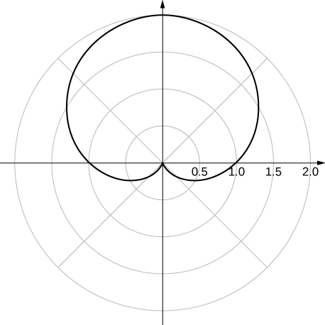

*y*-axis symmetry

169. 

Answer:

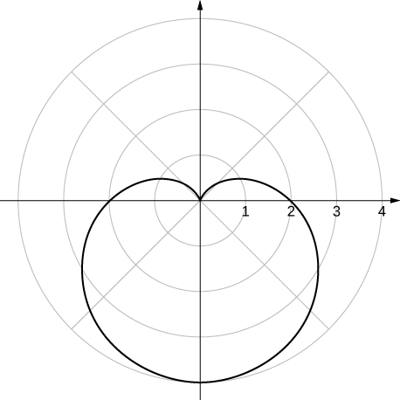

*y*-axis symmetry

171. 

Answer:

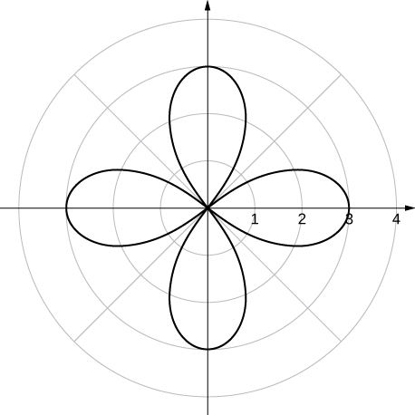

*x*- and *y*-axis symmetry and symmetry about the pole

173. 

Answer:

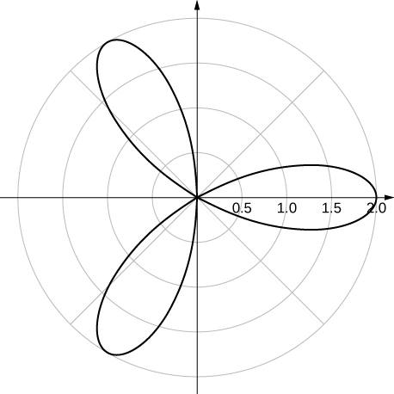

*x*-axis symmetry

175. 

Answer:

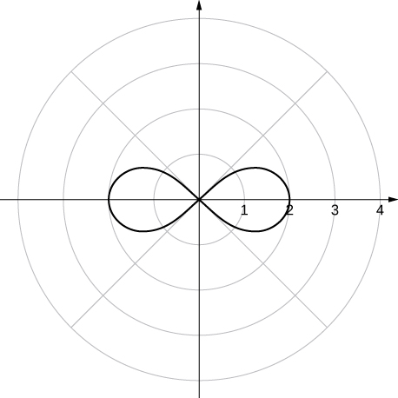

*x*- and *y*-axis symmetry and symmetry about the pole

177. 

Answer:

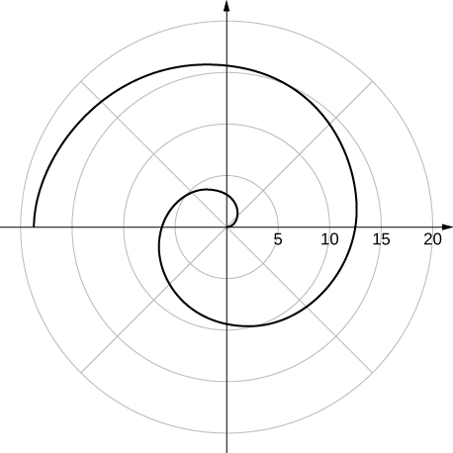

no symmetry

179. **[T]** Use a graphing utility and sketch the graph of 

Answer:

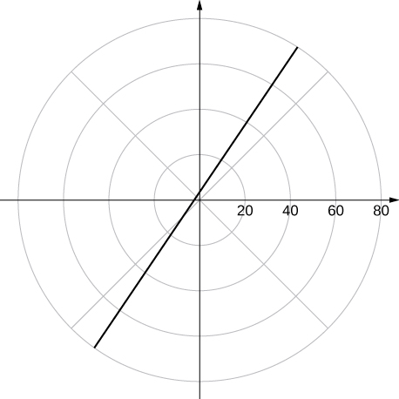

a line

181. **[T]** Use technology to graph 

Answer:

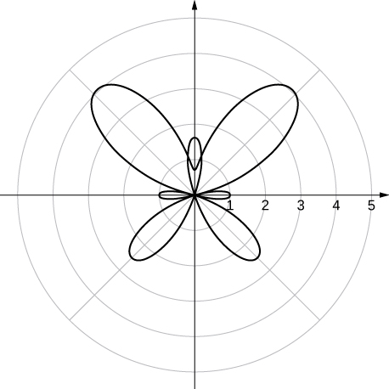

183. Without using technology, sketch the polar curve 

Answer:

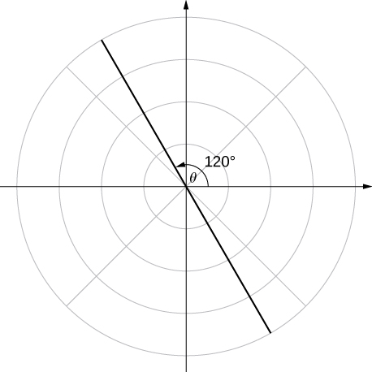

185. **[T]** Use technology to plot  for 

Answer:

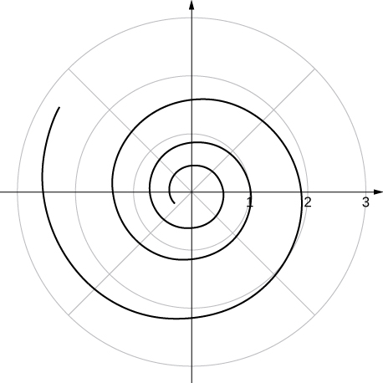

187. **[T]** Use the results of the preceding two problems to explore the graphs of and  for 

Answer: Answers vary. One possibility is the spiral lines become closer together and the total number of spirals increases.

This file is copyright 2016, Rice University. All Rights Reserved.